# Tyrel’s Journey’s to Deep learning Mastery

Intro

These article function to reinforce what I have learnt in my Deep Learning

## Face Recognition

What is Facial recognition?

Facial recognition system is a technology able to identify or verify a person’s identity from an image.

They are two modes in which a Facial Recognition system is built:

* Face Verification – This is a mapping of one the input image to a known identity i.e. is this, this person.
* Face Identification – This is a mapping of one input image to those in a database.

The mode in which this piece will examine Facial Recognition in this piece is via Face Verification. The backbone of this Facial recognition system is a binary classifier that outputs whether the two input images are images of the same person or not or verify if the person in the input image is the same as some known identity.

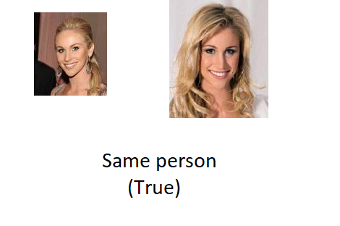

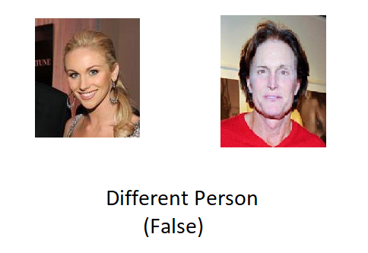

## Feature extraction

A pretrained network is used as the feature in extractor in this piece. Pre-trained networks are saved models that have been already trained on large datasets. Why use a pretrained network?....... Why the heck not? Why waste valuable time and money re-inventing the wheel? When you can build on what others have built. Additionally, pre-trained networks help in speeding up the training process and works well in cases where you don’t have much data. When used in this fashion it’s referred to as transfer learning. Most experts almost always use pre-trained models unless they are working on very specific problem.

The feature extractor will be a pretrained face net model with the top layer removed. This feature extract will extract a 128-dimensional vector encoding of the facial features of the input image.

The features of both the input image (unknown identity) and the known identity will be extracted via the same feature extractor producing two feature vectors for each image (known and unknown).Then a distance function is used to compute the distance between the feature vectors in their vector space which is then passed to a Binary classifier.

This arrangement is called a Siamese network.

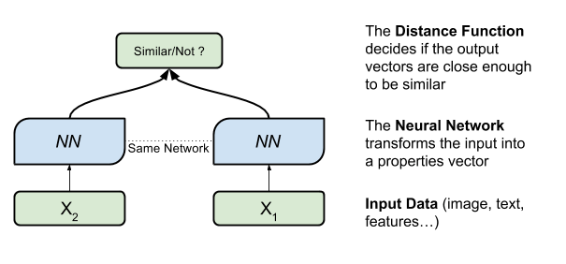

So, what is a binary classifier? A binary classifier is basically a machine learning algorithm that based on input features into the algorithm, predicts or classifies whether the features inputted features are of a certain class or not.



In the context of our current subject Facial Recognition, the classifier predicts whether the facial features are of a person in a database or not, or if there is any face in the database that is the same as the face in the input image.